Quince Orchard High School
All-School Booster Club Membership 2019-2020

Parent Name(s):_______________________________________________
Youngest Student at QOHS:__________________________ Grade:______
Best Phone to Reach You: ____________________ Email:______________
Home Address:________________________________________________

Annual Membership Levels and Benefits

___Booster $30
Receives Membership, Car Magnet and QOHS Directory

___Cougar Booster $50
Receives Membership, Car Magnet, QOHS Directory, and QOHS Tote Bag

___Red Army Booster $100
Receives Membership, Car Magnet, QOHS Directory, QOHS Beanie + $5 Cougar Cash for Spiritwear

___Hall of Fame Booster $175
Receives Membership, Car Magnet, QOHS Directory, QOHS Tote Bag AND QOHS Beanie (or blanket) + $10 Cougar Cash for Spiritwear

___Cougar Fan Club -- For QOHS Faculty, Staff, & Coaches ONLY $5
Includes QOHS Directory App & Car Magnet

Additional Donation to Booster Club $______
----------------------------------------------------------------------------------------------------------------------------------------------------
Total Amount $_______
(check payable to QOHS Booster Club)
Credit card payments can only be completed in person at school events OR online at www.qohsboosters.com

Mail form with payment to: Membership Chair
QOHS Booster Club
15800 Quince Orchard Rd., Gaithersburg, MD 20878

Questions? Jen Feinstein and Robin Kaufman qomembership@gmail.com

Incentives will be available for pick up at home football games, Back to School Night, and Fall Sports Nights.

Please note: Memberships are renewed each school year

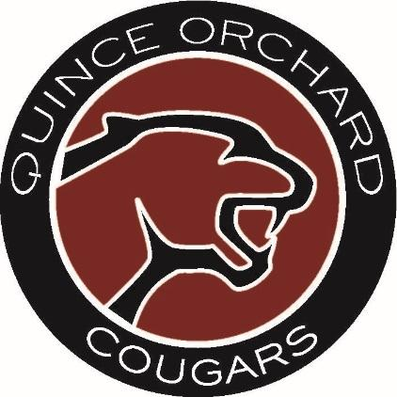

JOIN TODAY!!

The Booster Club supports ALL extra-curricular activities at QOHS. In the 2018/2019 school year the Booster Club contributed over $30K to school programs, events, clubs and activities such as:

- New mats for the Wrestling room
- Grant for the Every 15 Minutes Club
- Buses for students to travel to the State Football Championship Game
- New Softball outfield fence
- New Baseball pitching mound and home plate tarp
- State Championship Banners
- Grants for The Prowler and The Literary Club
- Football field grass conversion

We can’t do it without your support!

Visit the Booster Club website at

www.qohsboosters.com

Once your membership renewal has been processed you will receive the weekly Booster Club update.

